5K Charity Run/Walk
Feed My Starving Children
 | Date: September 7, 2019  Time: 8:00 AM  Location: Green Bay Community Church  600 Cardinal Lane  Green Bay, WI 54313 | 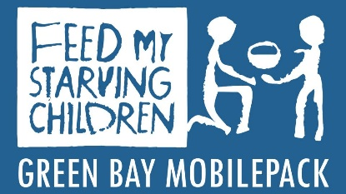
One registration form is required per participant (family). Or, register online at greenbaymobilepack.org
Last Name _________________________________________First Name_________________________ Address______________________________________________________________________________ City___________________State___________Zip___________Phone____________________________
Email_________________________________________
T-Shirts guaranteed to all participants registered by 8/22/19. Those registering after 8/22/19 will receive t-shirts on a first-come first-served basis. This is a timed run. Due to safety concerns, no pets.
Name | Birthdate | Gender  (M/ F) | Youth:  (S, M, L) | Adult: (S, M, L,  XL, XXL) | Long Sleeve or Dri Fit Shirt | Adult $25  Youth $15  Long Sleeve add $5  Dri-Fit add $5
Total:
Payment: Adult: $25 ($5 extra for long sleeve or dri-fit t-shirt)
Youth: (6 to 15): 15 (Under 5 free – no t-shirt)
Enclosed is my check for $_____________ payable to Green Bay Community Church/FMSC GB 5K Run
Waiver: I hereby declare, assert and affirm that participation in Feed My Starving Children 5K Run/Walk is done having voluntarily and knowing assume ALL RISKS involved in this event. The immediate physical risks and hazards associated with normal, vigorous activity including (but not limited to) physical discomfort, fatigue, muscular soreness, falls, pulled or strained muscles, overuse injuries, heat stress, and the rare instance of abnormal responses of the cardio-respiratory system including heart arrhythmia, heart attack, stroke, and sudden death. In consideration of acceptance of this contract allowing my participation in the above event and intending to be legally bound thereby, I hereby for myself, my heirs, executors, administrators and assigns, WAIVE AND RELEASE any and all rights and claims for negligence, injuries, damages or losses that I may incur against all participating agencies involved in the above event.
Print Name _______________________________ Signature_________________________________
Print Name _______________________________ Signature_________________________________
Date__________________ Parent/Legal Guardian must sign above if participant is under the age of 18
Send your completed form to: Green Bay Community Church, PO Box 10104, Green Bay, WI 54307 or drop it off at Green Bay Community Church.

